**Ciaran Duggan**

**C23380123**

**Algorithms & Data Structures**

**Assignment**

**Code Done in Cooperation With:**

**Tim Tector & Gavin Walsh**

**Introduction and Explanation**

* This is a report on the Java Program implementation of graph algorithms. There are two files: **PrimDijkstraDFBF.java** and **Dijkstra.java**.
* The graph is represented in an adjacency list in the file **wGraph.txt** that the PrimDijkstraDFBF file reads and constructs the graph from.
* The list's first line contains how many nodes and how many vertices are in the graph. Each subsequent line has three values: the starting vertex, the end vertex and the weight of the edge.

Depth First: The Depth First Search is an algorithm that searches every node in a data structure, starting from a given root node. In this program it is located in the file **PrimDijkstraDFBF.java**. It initialises the visited[] array to 0 and begins searching from its given root vertex. Using recursion it searches the graph as far as possible until it has to backtrack. It keeps calling itself until every vertex has been visited and outputs each vertex it visits as it goes.

Breadth First: The Breath First Search is an algorithm that searches every node in a data structure, starting from a given root node. In this program it is located in the file **PrimDijkstraDFBF.java**. It initialises the visited[] array to 0 and begins searching from its given root vertex. It creates a queue and adds the starting vertex to the queue. While the queue isn't empty, and the next vertex hasn't been visited, the selected node is added to the visited[] array and outputs this. The next node is added to the queue, then visited until all have been.

Prim's Algorithm: Prim's algorithm is a greedy algorithm that finds a minimum spanning tree for a connected weighted undirected graph. In this program it is located in the file **PrimDijkstraDFBF.java**. It finds a subset of the edges that form a tree which includes every vertex, where the total weight of all the edges in the tree is as small as possible. This was implemented using a heap and linked lists.

Dijkstra's Algorithm: Dijkstra's Algorithms is an algorithm that finds the shortest path between two vertices in a graph. It requires a start vertex and a destination vertex. It chooses the shortest vertex each time until it has reached the destination and seeks to find the shortest path. This was implemented using a heap and linked lists. Dijkstra’s algorithm was used in both files. The file **Dijkstra.java** takes in a .txt file of large a real world road network with nodes and weights. A note of the run timeand memory usage was made on the algorithm.

**Adjacency lists diagram showing the graph representation of the sample graph:**

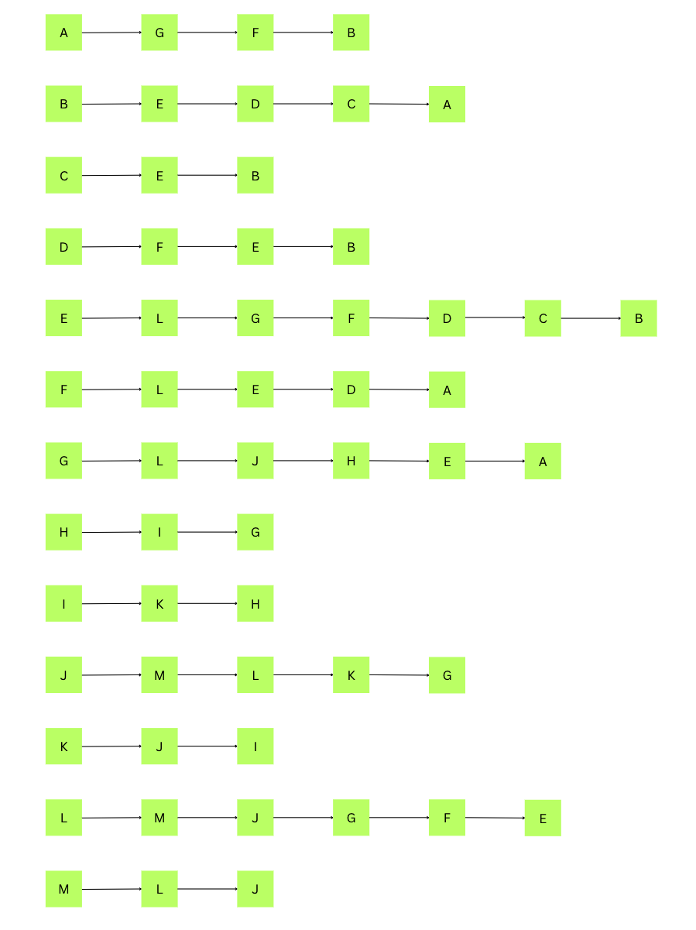

The adjacency list diagram above shows all the letters that are adjacent and connected to each letter starting with A through to M. For example, the letter A is adjacent to G, F and B.

**A step by step construction of the MST using Prim’s algorithm, starting from vertex L, for the sample graph. The contents of the heap, parent[] and dist[] arrays for each step in Prim are shown:**

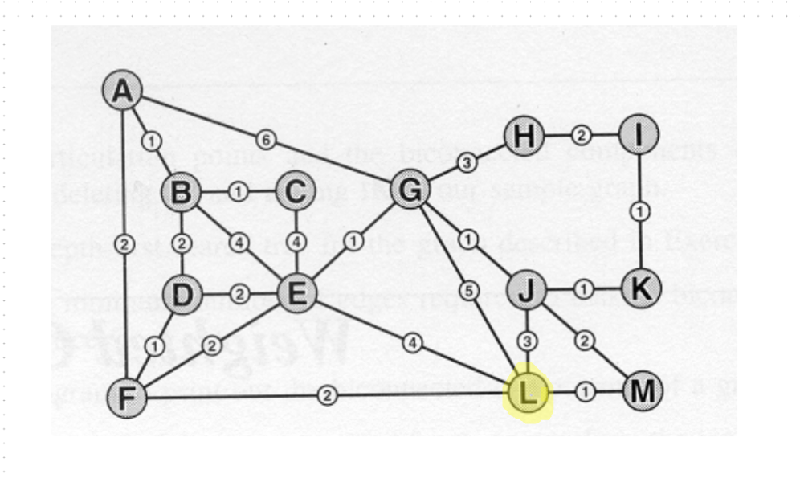

--- Step 0 ---

Prim - Step 0:

Heap: L(0)

dist[]: A=∞ B=∞ C=∞ D=∞ E=∞ F=∞ G=∞ H=∞ I=∞ J=∞ K=∞ L=0 M=∞

parent[]: A=null B=null C=null D=null E=null F=null G=null H=null I=null J=null K=null L=null M=null

Selected from heap: L (dist=0)

L is selected as the first letter.

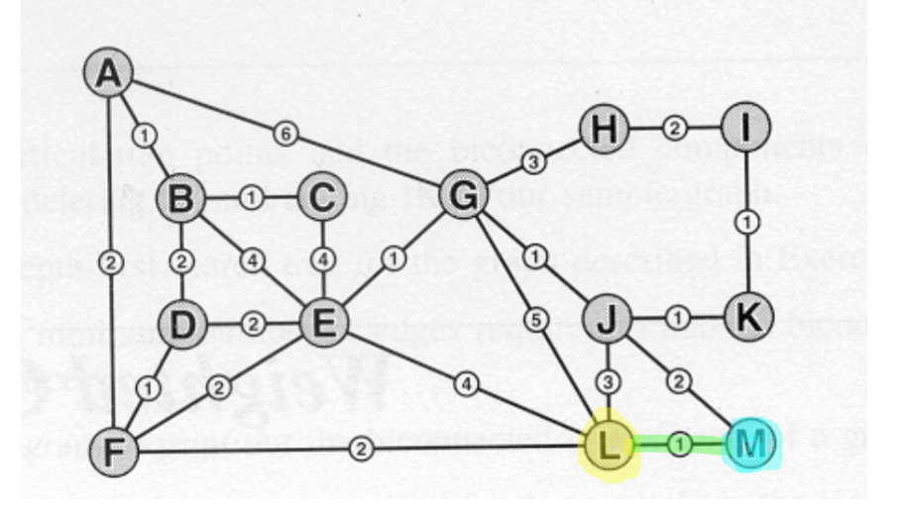

--- Step 1 ---

Prim - Step 1:

Heap: M(1) F(2) G(5) J(3) E(4)

dist[]: A=∞ B=∞ C=∞ D=∞ E=4 F=2 G=5 H=∞ I=∞ J=3 K=∞ L=0 M=1

parent []: A=null B=null C=null D=null E=L F=L G=L H=null I=null J=L K=null L=null M=L

Selected from heap: M (dist=1)

L is connected to M and has distance of 1, F distance of 2, G distance of 5, J distance of 3 and E distance of 4. Each of these distances are added to the dist [ ] array and stored alongside their letters. Each letter L is connected to also now has L as their parent.

M is now selected as it has the least distance.

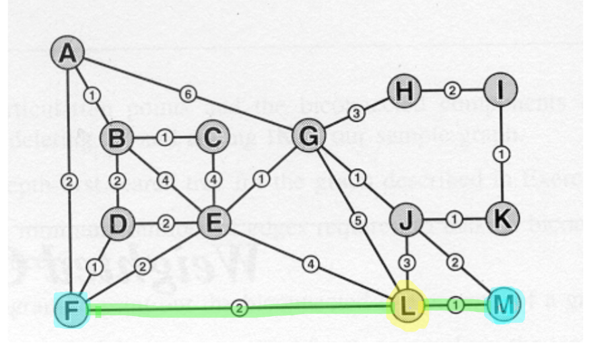

--- Step 2 ---

Prim - Step 2:

Heap: F(2) J(2) G(5) E(4)

dist[]: A=∞ B=∞ C=∞ D=∞ E=4 F=2 G=5 H=∞ I=∞ J=2 K=∞ L=0 M=1

parent[]: A=null B=null C=null D=null E=L F=L G=L H=null I=null J=M K=null L=null M=L

Selected from heap: F (dist=2)

After M is selected the heap does not change as there are no new letters connected to M that were not connected to L. However, the distance of J is updated as M is closer and therefore the parent of J is updated to M.  
F is selected as it has the shortest distance and was in the heap first.

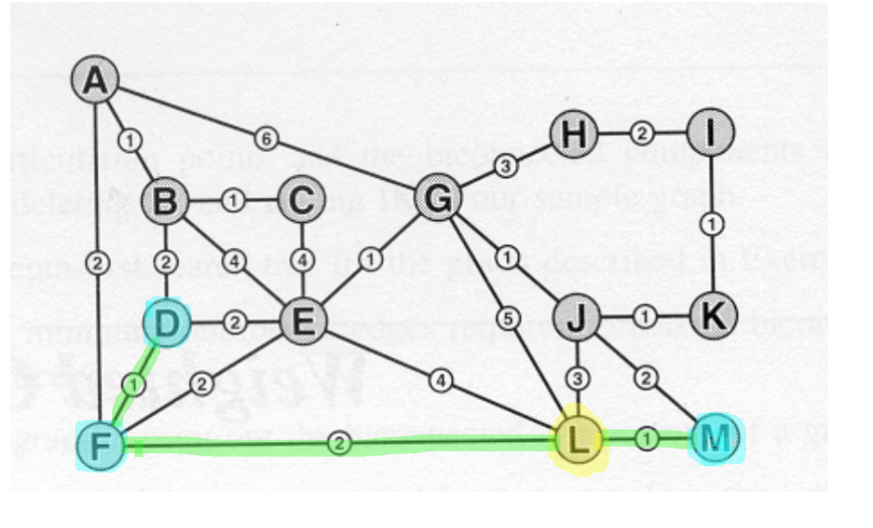

--- Step 3 ---

Prim - Step 3:

Heap: D(1) J(2) G(5) E(2) A(2)

dist[]: A=2 B=∞ C=∞ D=1 E=2 F=2 G=5 H=∞ I=∞ J=2 K=∞ L=0 M=1

parent[]: A=F B=null C=null D=F E=F F=L G=L H=null I=null J=M K=null L=null M=L

Selected from heap: D (dist=1)  
D is added to the heap with weight = 1, along with A with weight = 2.

E is updated to weight = 2.

Their distances are added and changed in the distance array. Parent array is also updated.

D is then selected.

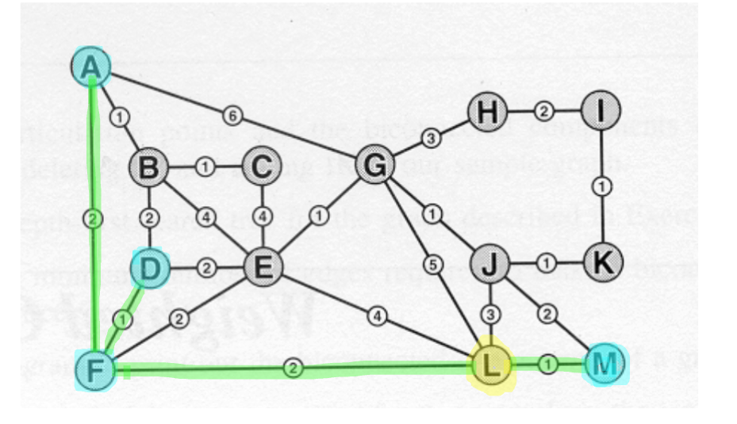

--- Step 4 ---

Prim - Step 4:

Heap: A(2) J(2) G(5) E(2) B(2)

dist[]: A=2 B=2 C=∞ D=1 E=2 F=2 G=5 H=∞ I=∞ J=2 K=∞ L=0 M=1

parent[]: A=F B=D C=null D=F E=F F=L G=L H=null I=null J=M K=null L=null M=L

Selected from heap: A (dist=2)

B added to heap with weight = 2.

Next A is selected. There were multiple with the same weight so just select one with the lowest value.

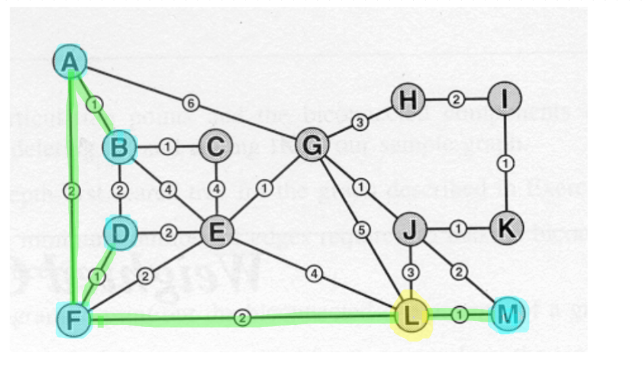

--- Step 5 ---

Prim - Step 5:

Heap: B(1) J(2) G(5) E(2)

dist[]: A=2 B=1 C=∞ D=1 E=2 F=2 G=5 H=∞ I=∞ J=2 K=∞ L=0 M=1

parent[]: A=F B=A C=null D=F E=F F=L G=L H=null I=null J=M K=null L=null M=L  
 Selected from heap: B (dist=1)

B is updated to weight = 1.

B is selected.

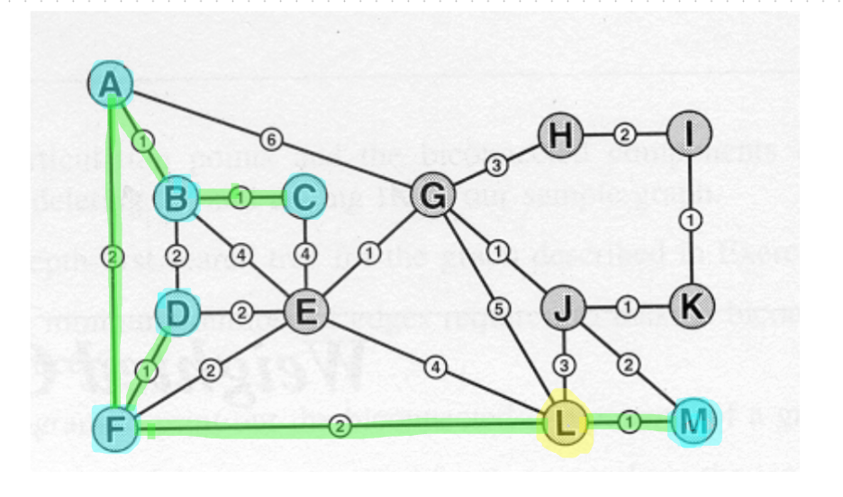

--- Step 6 ---

Prim - Step 6:

Heap: C(1) E(2) G(5) J(2)

dist[]: A=2 B=1 C=1 D=1 E=2 F=2 G=5 H=∞ I=∞ J=2 K=∞ L=0 M=1

parent[]: A=F B=A C=B D=F E=F F=L G=L H=null I=null J=M K=null L=null M=L

Selected from heap: C (dist=1)  
C is added to heap with weight = 1.

C is selected.

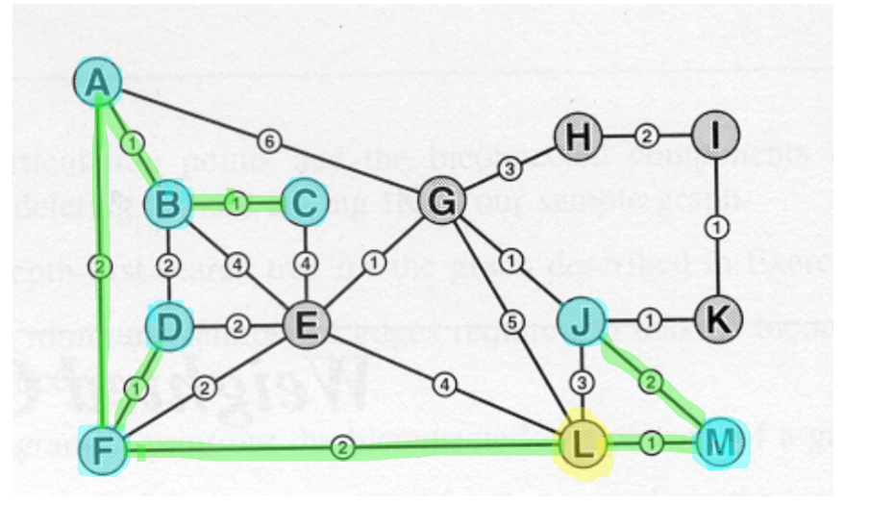

--- Step 7 ---

Prim - Step 7:

Heap: J(2) E(2) G(5)

dist[]: A=2 B=1 C=1 D=1 E=2 F=2 G=5 H=∞ I=∞ J=2 K=∞ L=0 M=1

parent[]: A=F B=A C=B D=F E=F F=L G=L H=null I=null J=M K=null L=null M=L

Selected from heap: J (dist=2)  
J is selected.

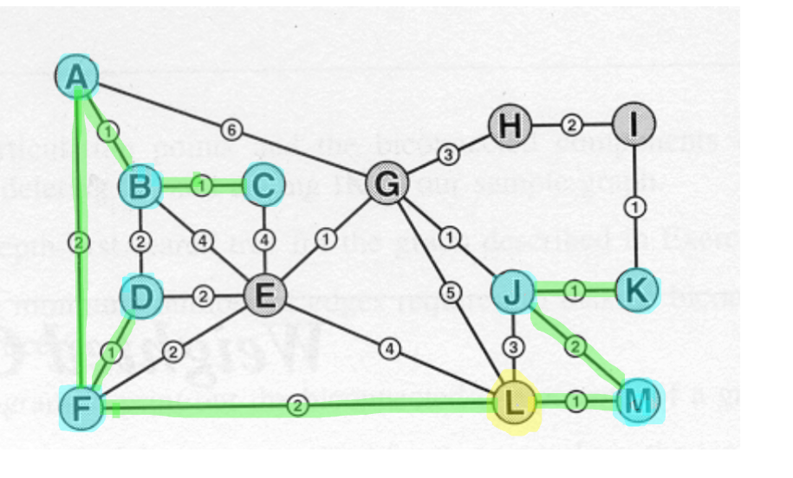

--- Step 8 ---

Prim - Step 8:

Heap: K(1) G(1) E(2)

dist[]: A=2 B=1 C=1 D=1 E=2 F=2 G=1 H=∞ I=∞ J=2 K=1 L=0 M=1

parent[]: A=F B=A C=B D=F E=F F=L G=J H=null I=null J=M K=J L=null M=L

Selected from heap: K (dist=1)  
K added to heap with weight = 1.   
G updated to weight = 1.  
K selected.

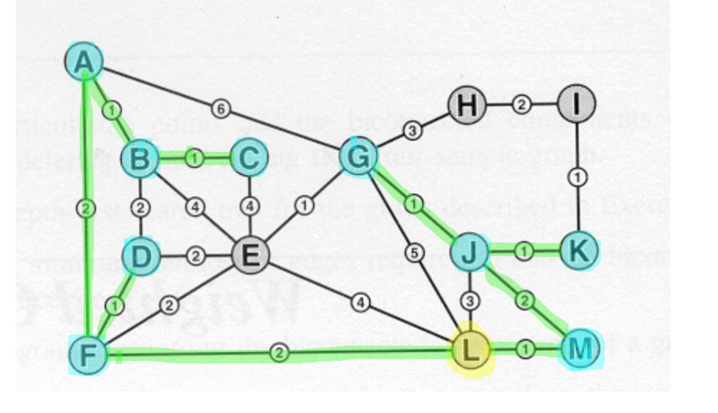

--- Step 9 ---

Prim - Step 9:

Heap: G(1) E(2) I(1)

dist[]: A=2 B=1 C=1 D=1 E=2 F=2 G=1 H=∞ I=1 J=2 K=1 L=0 M=1

parent[]: A=F B=A C=B D=F E=F F=L G=J H=null I=K J=M K=J L=null M=L

Selected from heap: G (dist=1)  
I added to heap with weight = 1.

G is selected.

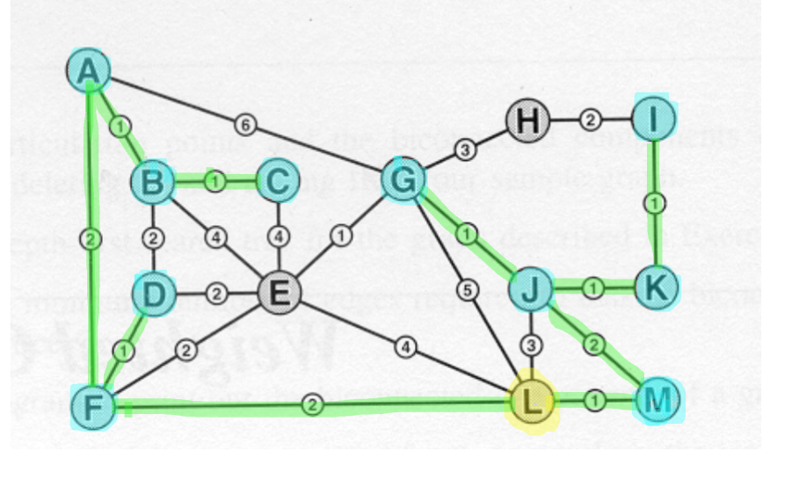

--- Step 10 ---

Prim - Step 10:

Heap: I(1) E(1) H(3)

dist[]: A=2 B=1 C=1 D=1 E=1 F=2 G=1 H=3 I=1 J=2 K=1 L=0 M=1

parent[]: A=F B=A C=B D=F E=G F=L G=J H=G I=K J=M K=J L=null M=L

Selected from heap: I (dist=1)

H added to heap with weight = 3.

E updated to weight = 1.

I selected.

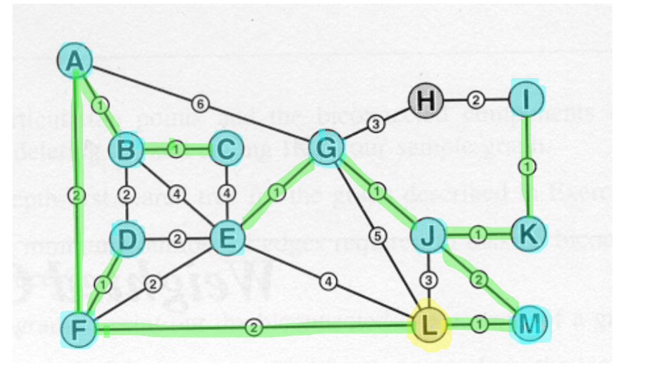

--- Step 11 ---

Prim - Step 11:

Heap: E(1) H(2)

dist[]: A=2 B=1 C=1 D=1 E=1 F=2 G=1 H=2 I=1 J=2 K=1 L=0 M=1

parent[]: A=F B=A C=B D=F E=G F=L G=J H=I I=K J=M K=J L=null M=L

Selected from heap: E (dist=1)

H updated to weight = 2.  
E is selected.

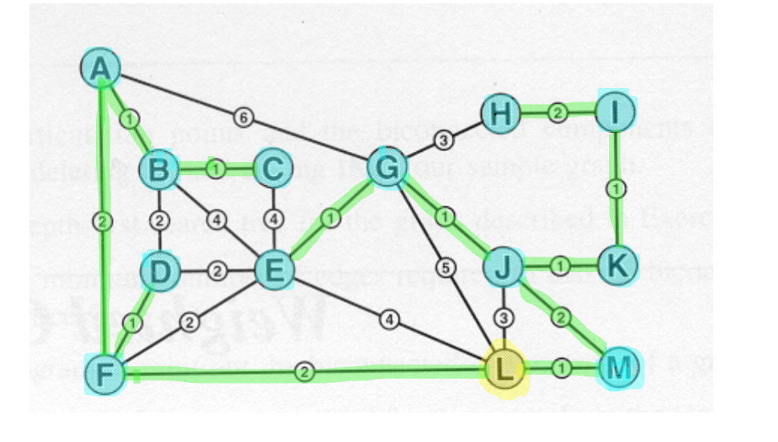

--- Step 12 ---

Prim - Step 12:

Heap: H(2)

dist[]: A=2 B=1 C=1 D=1 E=1 F=2 G=1 H=2 I=1 J=2 K=1 L=0 M=1

parent[]: A=F B=A C=B D=F E=G F=L G=J H=I I=K J=M K=J L=null M=L

Selected from heap: H (dist=2)

H is selected

**Next is the shortest path to each letter from vertex L using Dijkstras algorithm:**

L -> A Dist: 4 Path: L -> F -> A

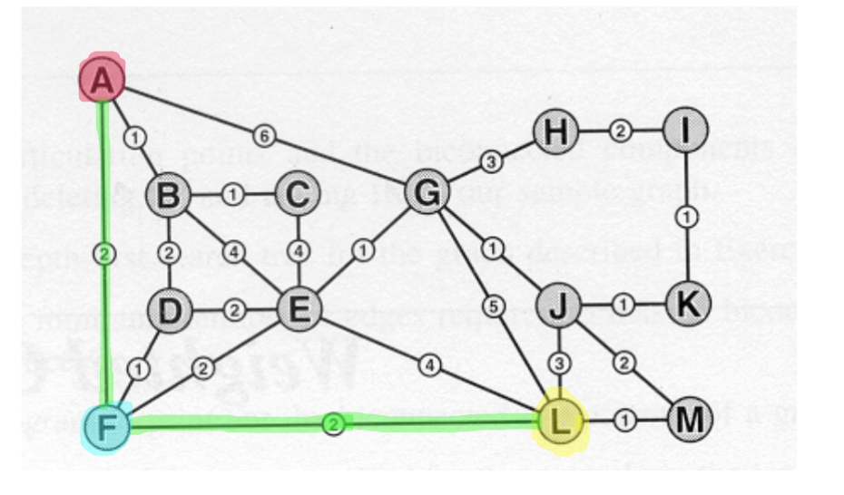

L -> B Dist: 5 Path: L -> F -> D -> B

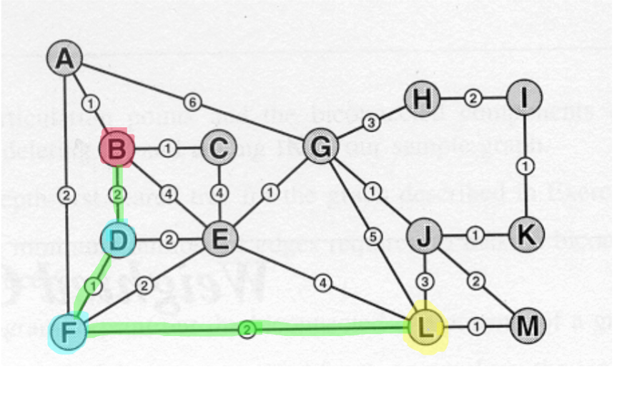

L -> C Dist: 6 Path: L -> F -> D -> B -> C

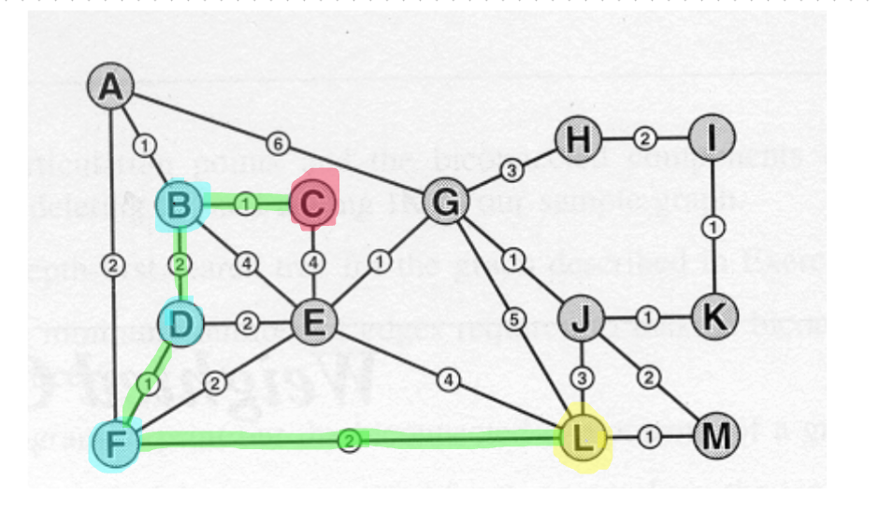

L -> D Dist: 3 Path: L -> F -> D

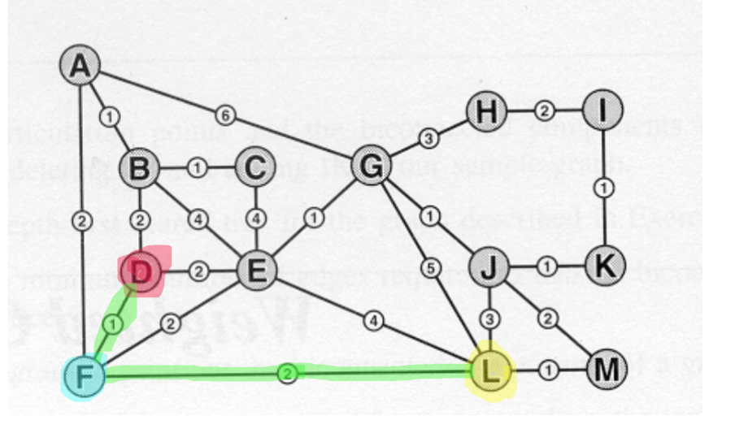

L -> E Dist: 4 Path: L -> E

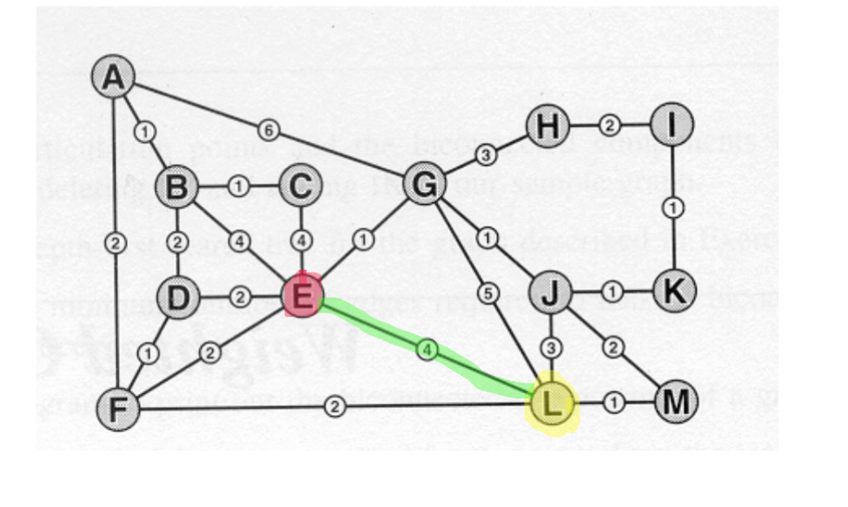

L -> F Dist: 2 Path: L -> F

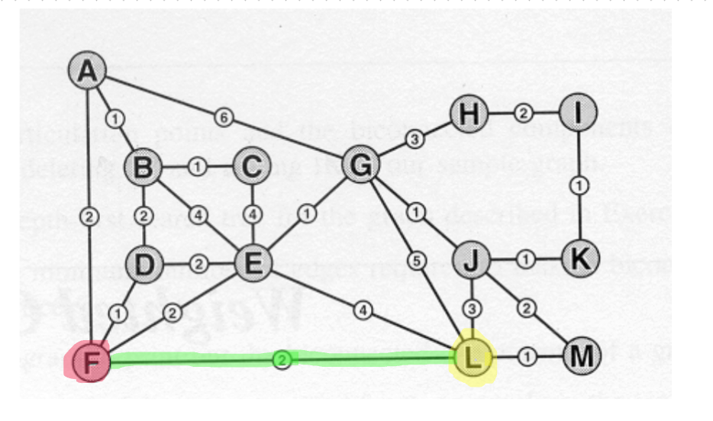

L -> G Dist: 4 Path: L -> J -> G

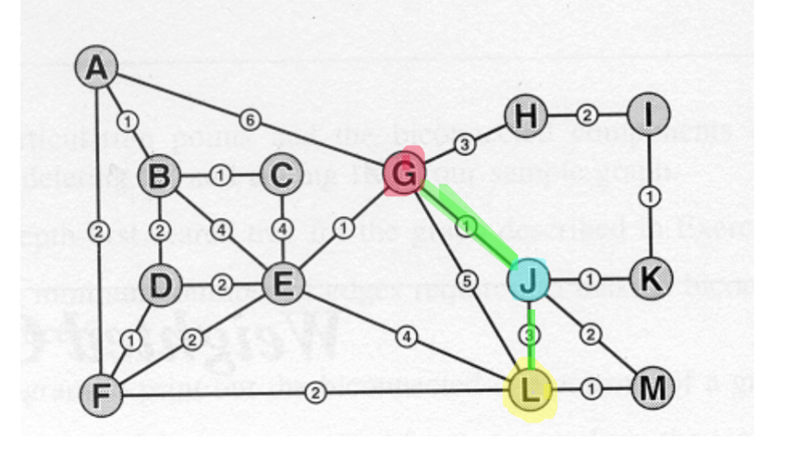

L -> H Dist: 7 Path: L -> J -> G -> H

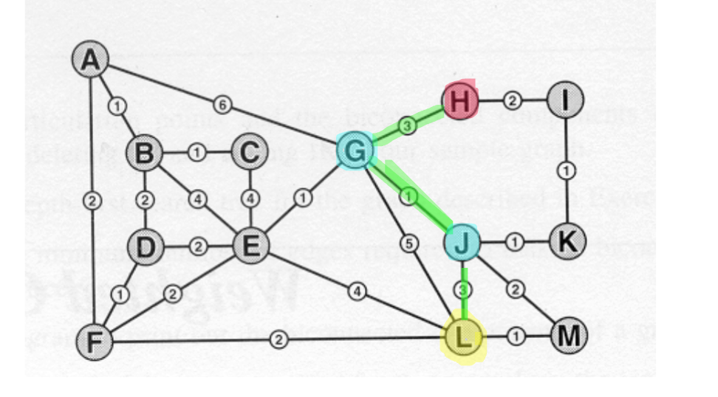

L -> I Dist: 5 Path: L -> J -> K -> I

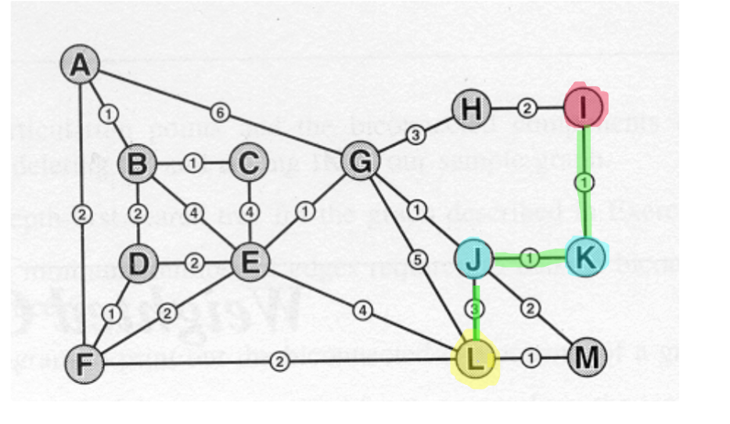

L -> J Dist: 3 Path: L -> J

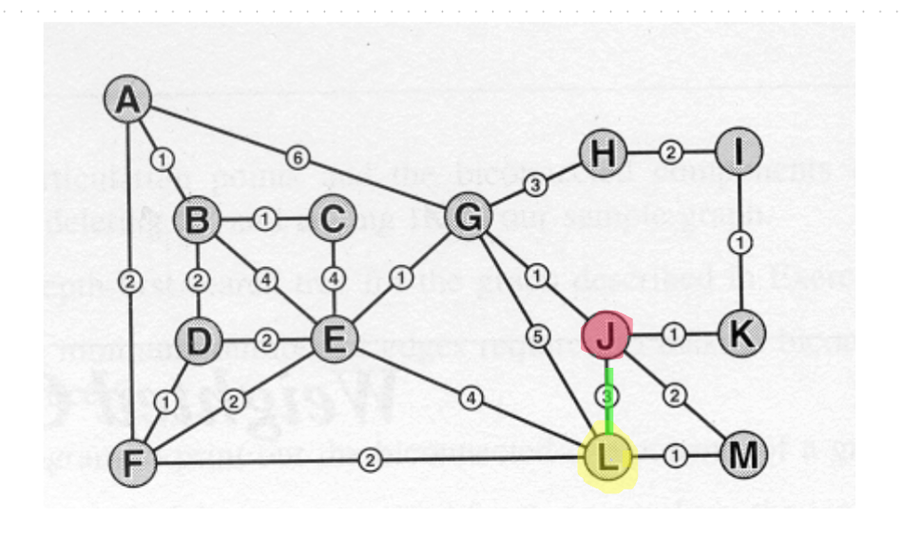

L -> K Dist: 4 Path: L -> J -> K

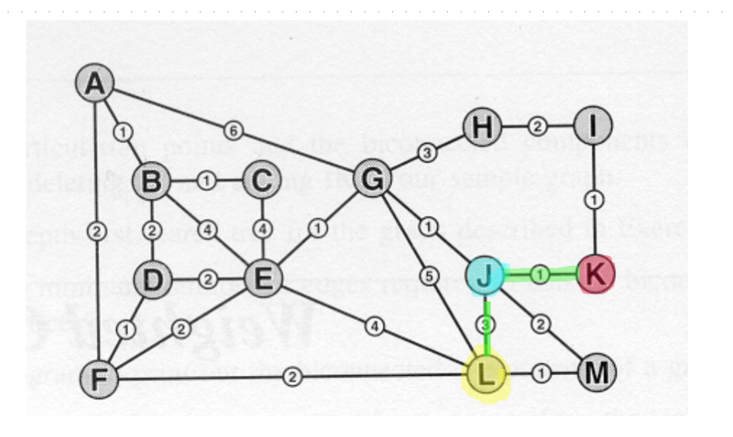

L -> M Dist: 1 Path: L -> M

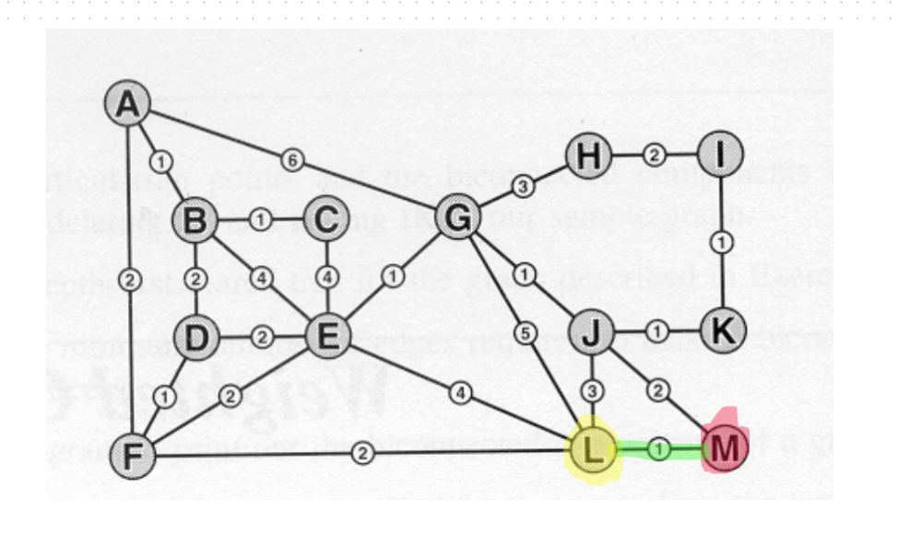

**A step by step construction of the SPT using Dijkstra’s algorithm, starting from vertex L, for the sample graph. The contents of the heap, parent[] and dist[] arrays for each step in Dijkstra are shown:**

Dijkstra - Step 1:

Heap: L(0)

dist[]: A=∞ B=∞ C=∞ D=∞ E=∞ F=∞ G=∞ H=∞ I=∞ J=∞ K=∞ L=0 M=∞

parent[]: A=null B=null C=null D=null E=null F=null G=null H=null I=null J=null K=null L=null M=null

Selected from heap: L (dist=0)

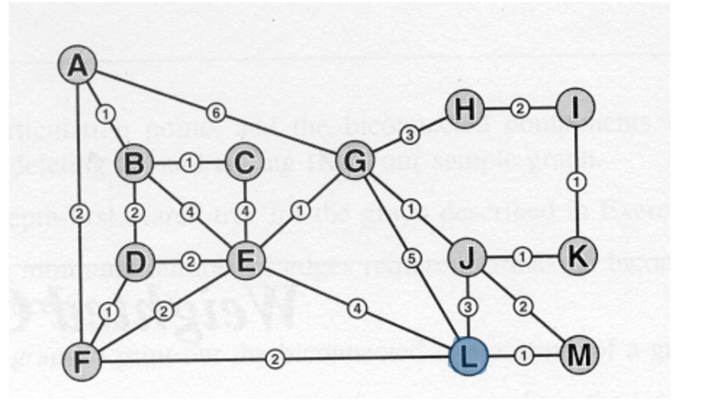

Dijkstra - Step 2:

Heap: M(1) F(2) G(5) J(3) E(4)

dist[]: A=∞ B=∞ C=∞ D=∞ E=4 F=2 G=5 H=∞ I=∞ J=3 K=∞ L=0 M=1

parent[]: A=null B=null C=null D=null E=L F=L G=L H=null I=null J=L K=null L=null M=L

Selected from heap: M (dist=1)

M selected as its closest.

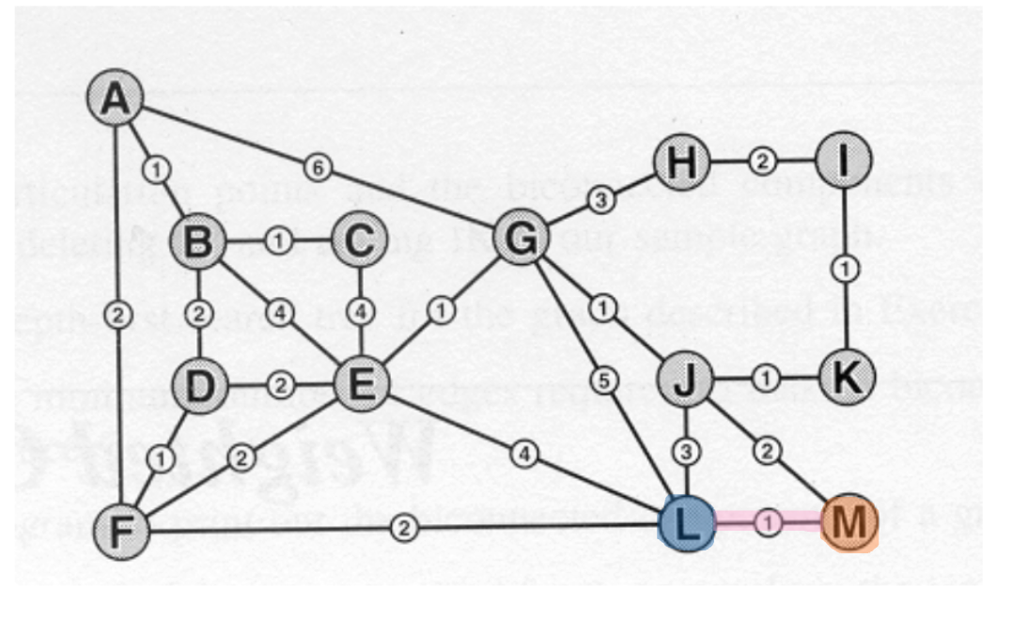

Dijkstra - Step 3:

Heap: F(2) J(3) G(5) E(4)

dist[]: A=∞ B=∞ C=∞ D=∞ E=4 F=2 G=5 H=∞ I=∞ J=3 K=∞ L=0 M=1

parent[]: A=null B=null C=null D=null E=L F=L G=L H=null I=null J=L K=null L=null M=L

Selected from heap: F (dist=2)

F next as it is now the closest not already selected

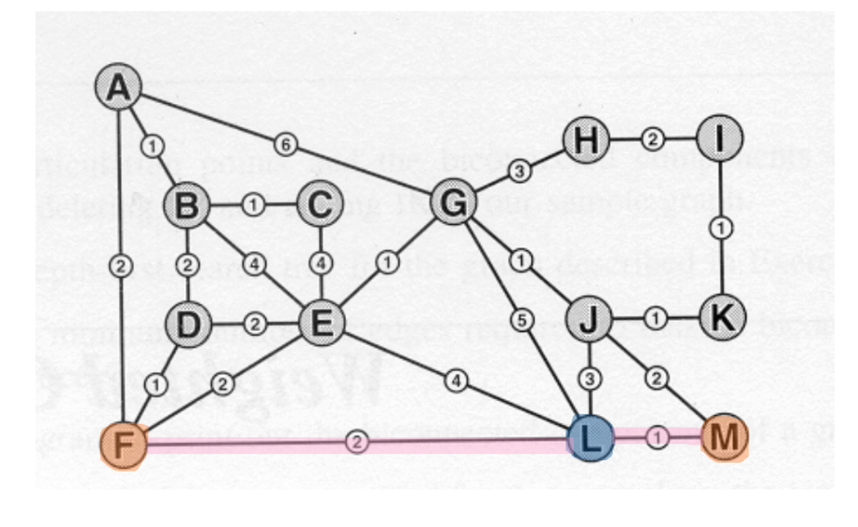

Dijkstra - Step 4:

Heap: J(3) D(3) G(5) E(4) A(4)

dist[]: A=4 B=∞ C=∞ D=3 E=4 F=2 G=5 H=∞ I=∞ J=3 K=∞ L=0 M=1

parent[]: A=F B=null C=null D=F E=L F=L G=L H=null I=null J=L K=null L=null M=L

Selected from heap: J (dist=3)

Now J for same reason.

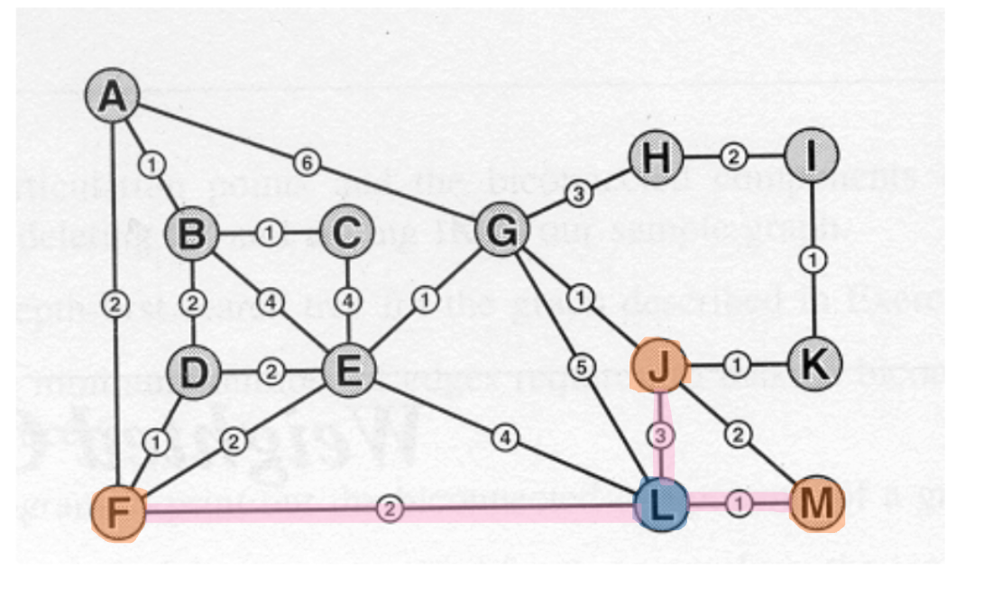

Dijkstra - Step 5:

Heap: D(3) A(4) G(4) E(4) K(4)

dist[]: A=4 B=∞ C=∞ D=3 E=4 F=2 G=4 H=∞ I=∞ J=3 K=4 L=0 M=1

parent[]: A=F B=null C=null D=F E=L F=L G=J H=null I=null J=L K=J L=null M=L

Selected from heap: D (dist=3)

D next as its 3 away (L-F = 2) + (F-D = 1) = 3

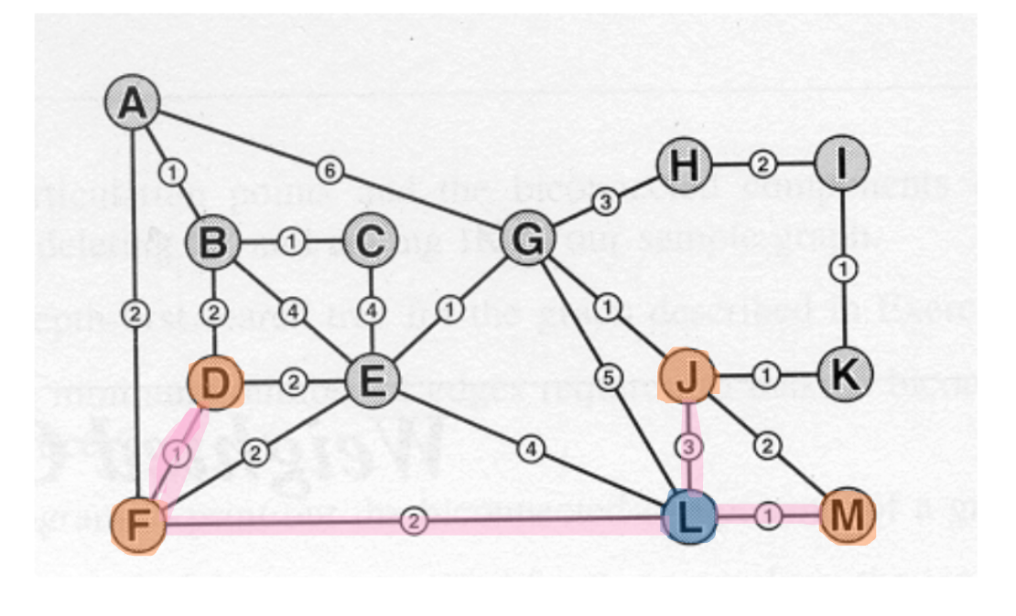

Dijkstra - Step 6:

Heap: K(4) A(4) G(4) E(4) B(5)

dist[]: A=4 B=5 C=∞ D=3 E=4 F=2 G=4 H=∞ I=∞ J=3 K=4 L=0 M=1

parent[]: A=F B=D C=null D=F E=L F=L G=J H=null I=null J=L K=J L=null M=L

Selected from heap: K (dist=4)

Next K through J. 3+1 = 4

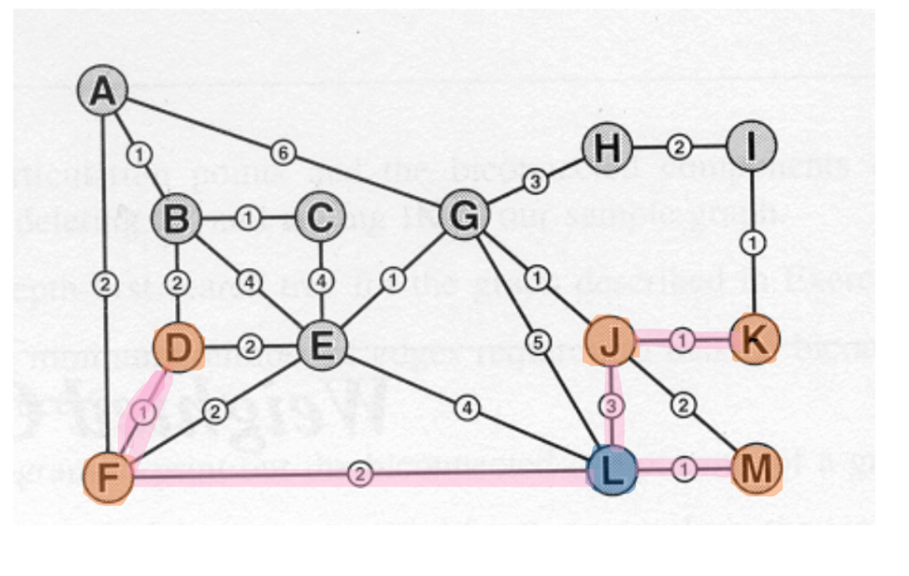

Dijkstra - Step 7:

Heap: A(4) E(4) G(4) B(5) I(5)

dist[]: A=4 B=5 C=∞ D=3 E=4 F=2 G=4 H=∞ I=5 J=3 K=4 L=0 M=1

parent[]: A=F B=D C=null D=F E=L F=L G=J H=null I=K J=L K=J L=null M=L

Selected from heap: A (dist=4)

Next A. L-F-A

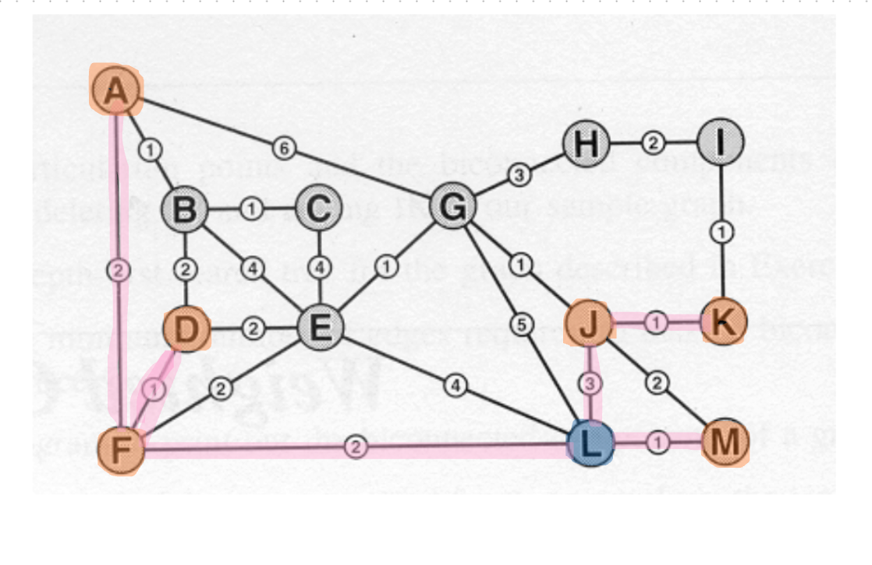

Dijkstra - Step 8:

Heap: E(4) I(5) G(4) B(5)

dist[]: A=4 B=5 C=∞ D=3 E=4 F=2 G=4 H=∞ I=5 J=3 K=4 L=0 M=1

parent[]: A=F B=D C=null D=F E=L F=L G=J H=null I=K J=L K=J L=null M=L

Selected from heap: E (dist=4)

Next E. L-E

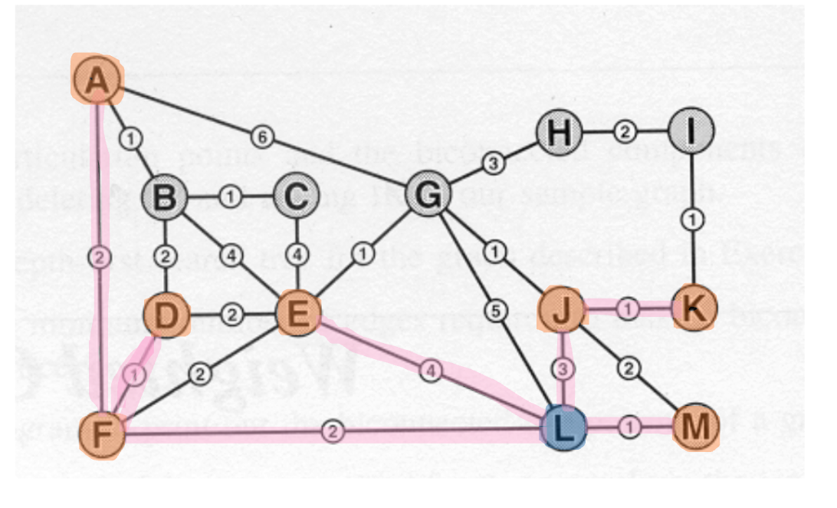

Dijkstra - Step 9:

Heap: G(4) I(5) B(5) C(8)

dist[]: A=4 B=5 C=8 D=3 E=4 F=2 G=4 H=∞ I=5 J=3 K=4 L=0 M=1

parent[]: A=F B=D C=E D=F E=L F=L G=J H=null I=K J=L K=J L=null M=L

Selected from heap: G (dist=4)

Next G. L-J-G

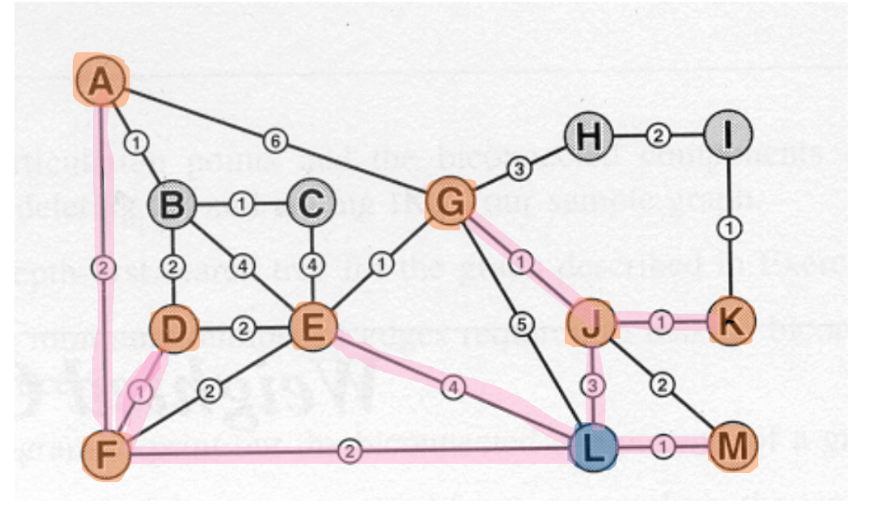

Dijkstra - Step 10:

Heap: I(5) H(7) B(5) C(8)

dist[]: A=4 B=5 C=8 D=3 E=4 F=2 G=4 H=7 I=5 J=3 K=4 L=0 M=1

parent[]: A=F B=D C=E D=F E=L F=L G=J H=G I=K J=L K=J L=null M=L

Selected from heap: I (dist=5)

Next I. L-J-K-I

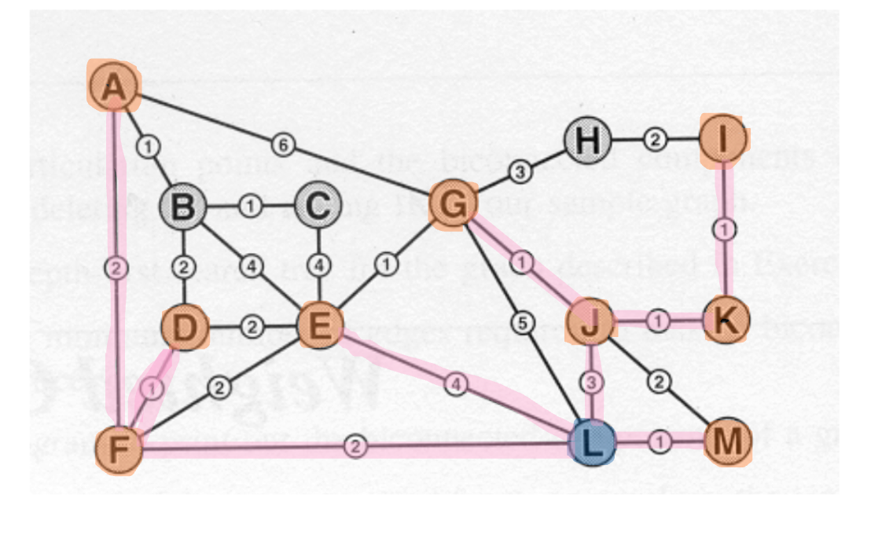

Dijkstra - Step 11:

Heap: B(5) H(7) C(8)

dist[]: A=4 B=5 C=8 D=3 E=4 F=2 G=4 H=7 I=5 J=3 K=4 L=0 M=1

parent[]: A=F B=D C=E D=F E=L F=L G=J H=G I=K J=L K=J L=null M=L

Selected from heap: B (dist=5)

Next B. L-F-D-B

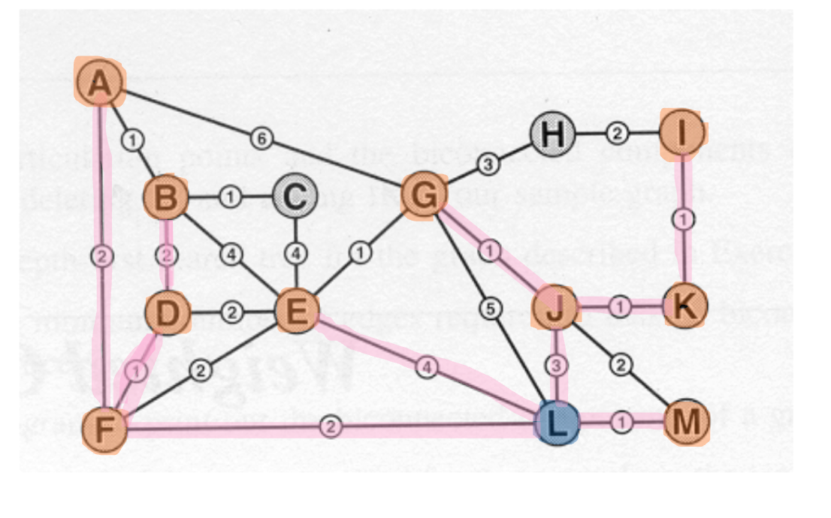

Dijkstra - Step 12:

Heap: C(6) H(7)

dist[]: A=4 B=5 C=6 D=3 E=4 F=2 G=4 H=7 I=5 J=3 K=4 L=0 M=1

parent[]: A=F B=D C=B D=F E=L F=L G=J H=G I=K J=L K=J L=null M=L

Selected from heap: C (dist=6)

Next C. L-F-D-B-C

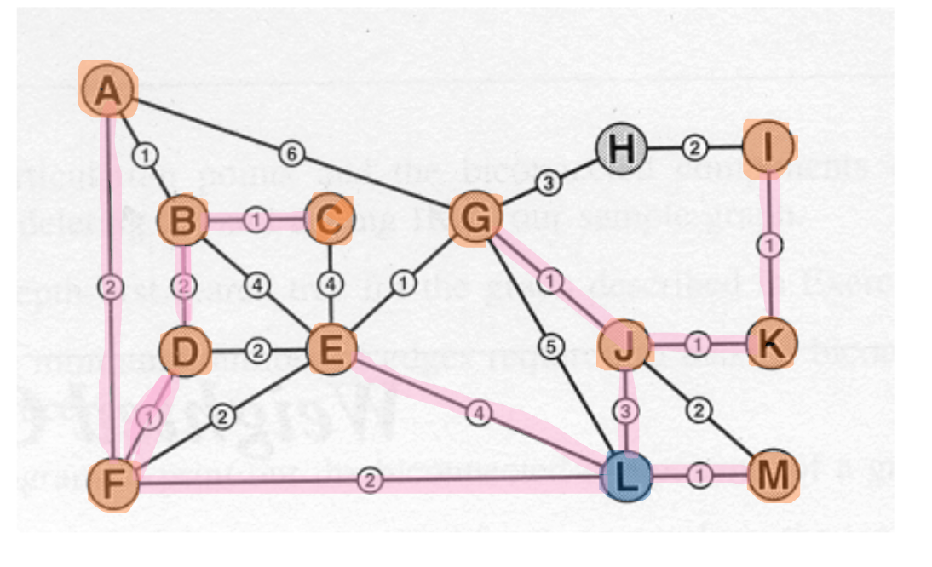

Dijkstra - Step 13:

Heap: H(7)

dist[]: A=4 B=5 C=6 D=3 E=4 F=2 G=4 H=7 I=5 J=3 K=4 L=0 M=1

parent[]: A=F B=D C=B D=F E=L F=L G=J H=G I=K J=L K=J L=null M=L

Selected from heap: H (dist=7)

Next H. L-J-G-H

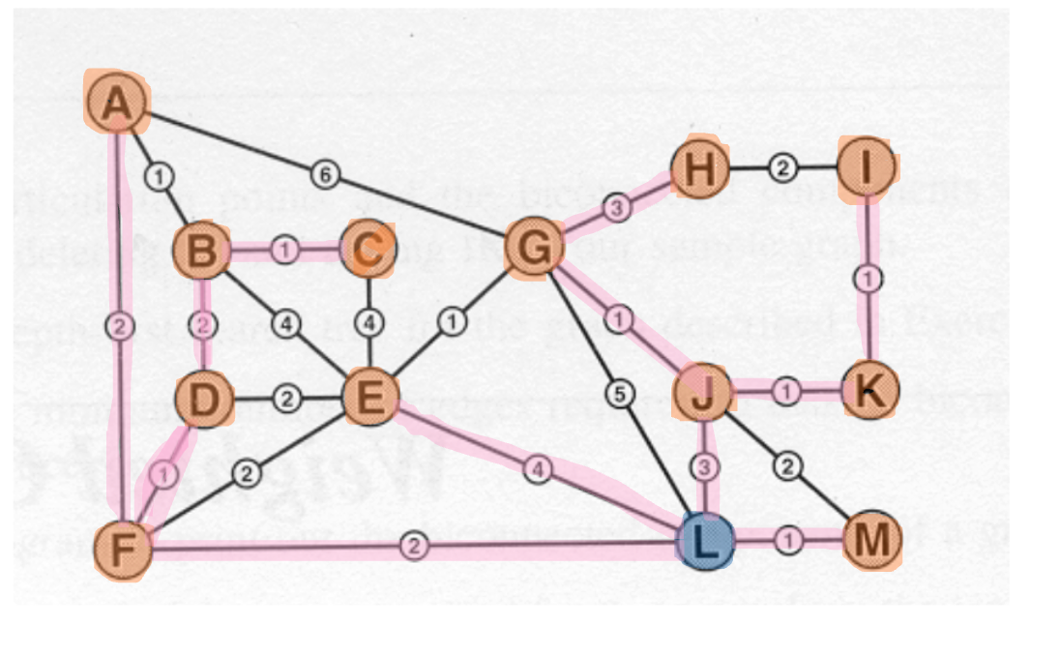  
  
  
OUPUTS:  
  
The first image shows each edge of the graph:

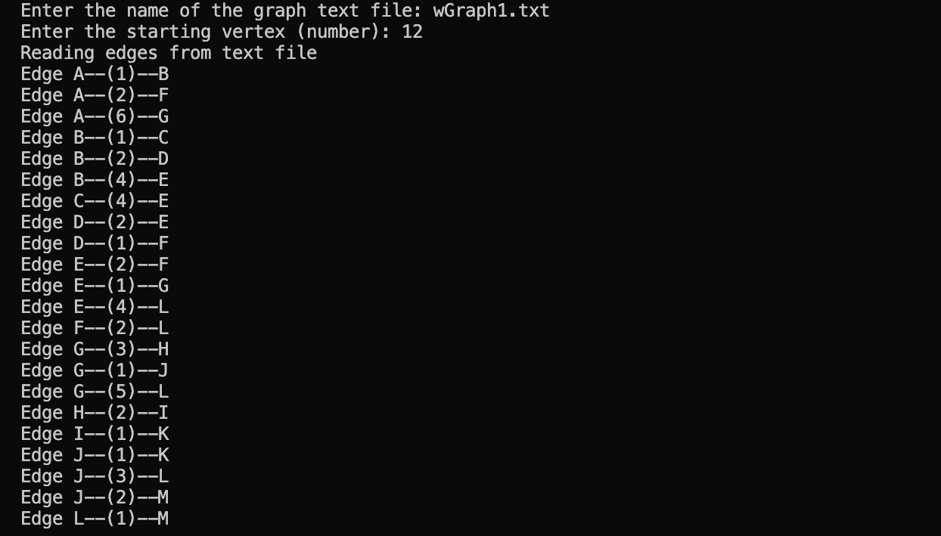

The second image is the adjacency list output:

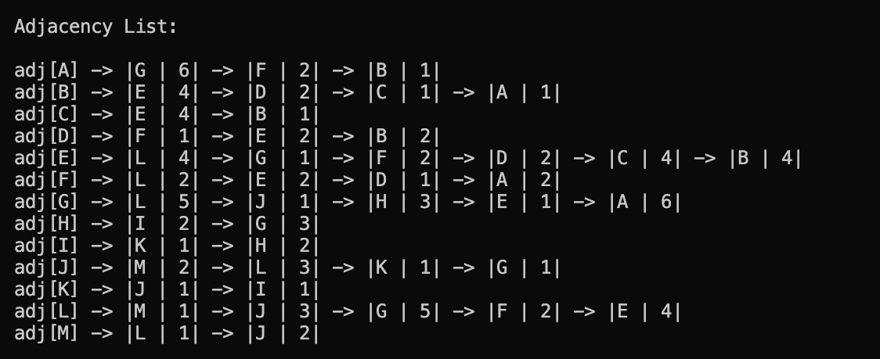

The next image is both the depth-first and breadth-first traversals shown in an adjacency list format.

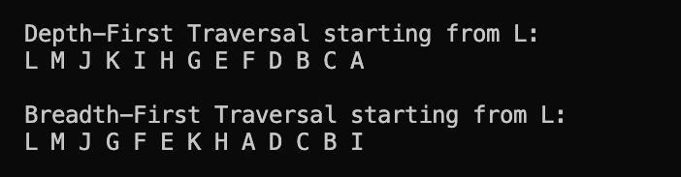

The next images show the output of prims algorithm on the graph. They also have the MST which show the parent of each letter in the graph traversal.

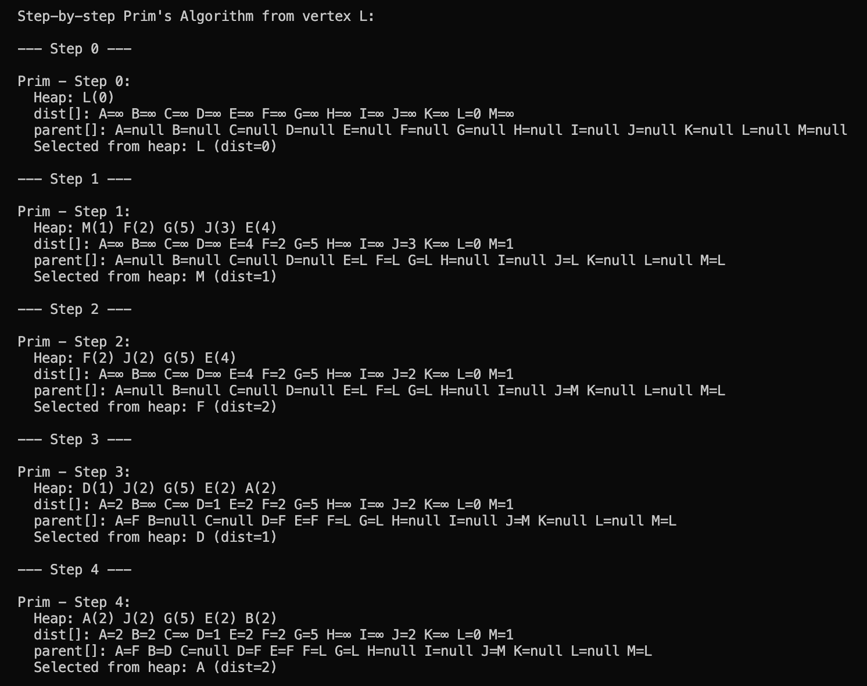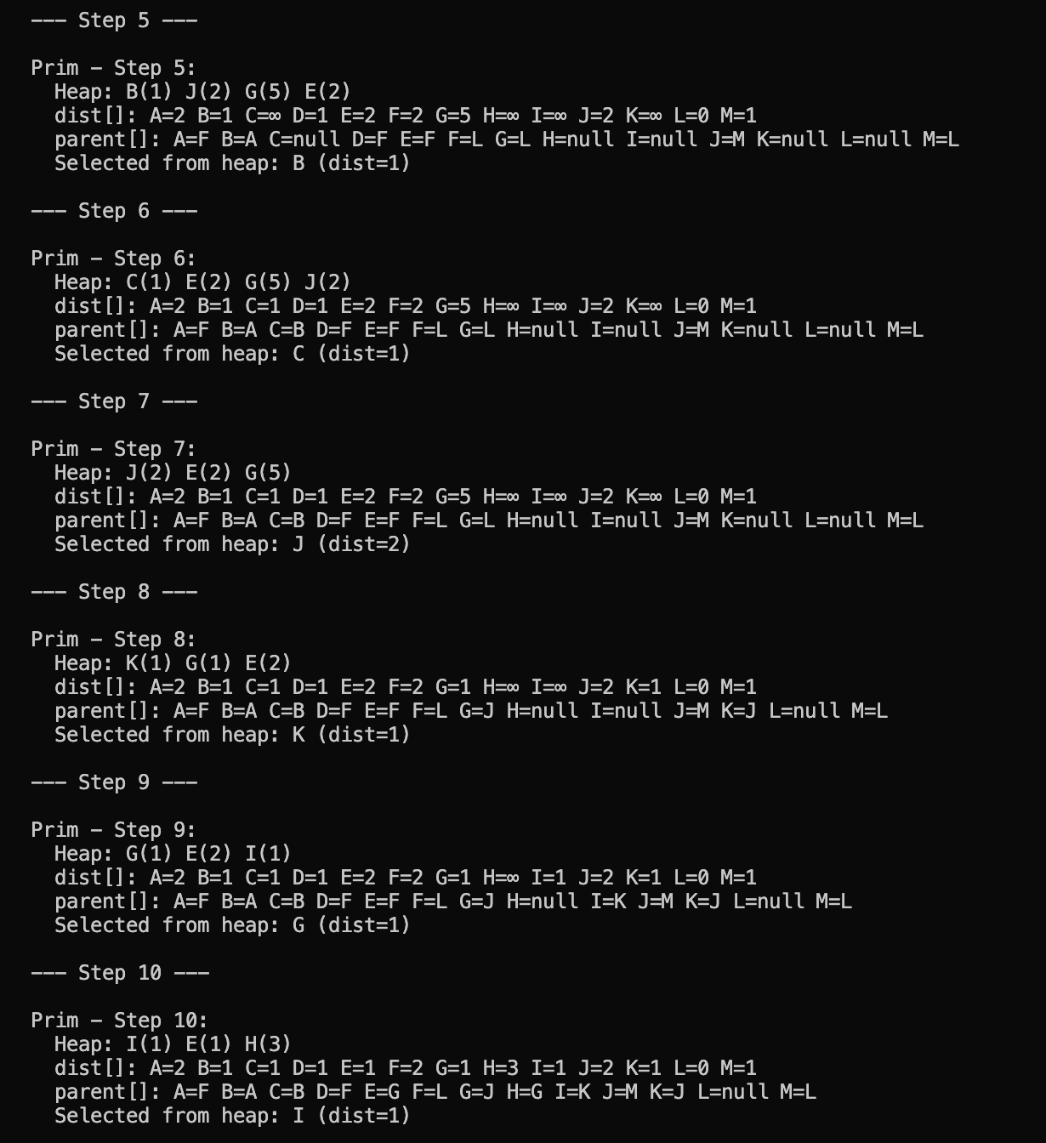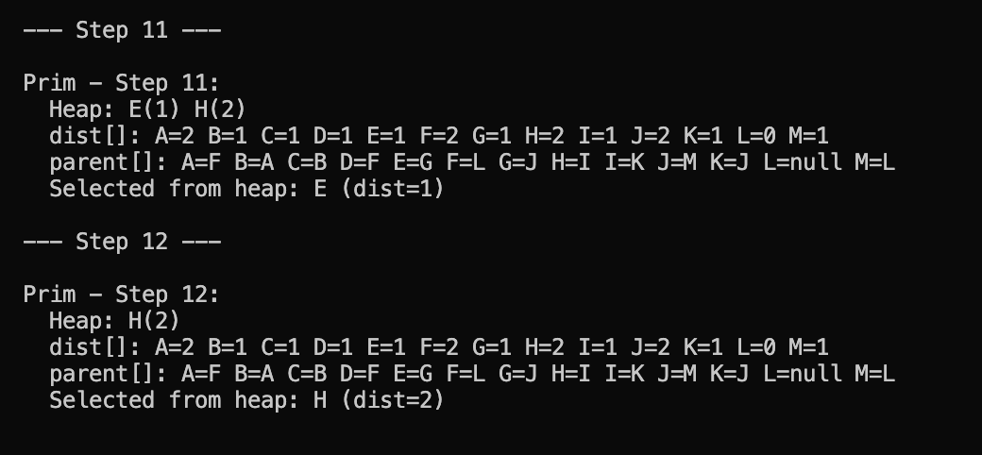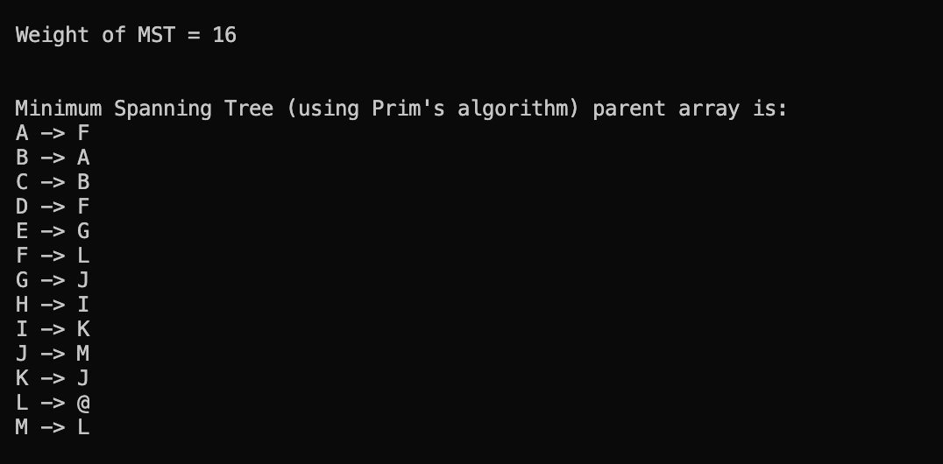

The next images show Dijkstras algorithm traversing through the graph.

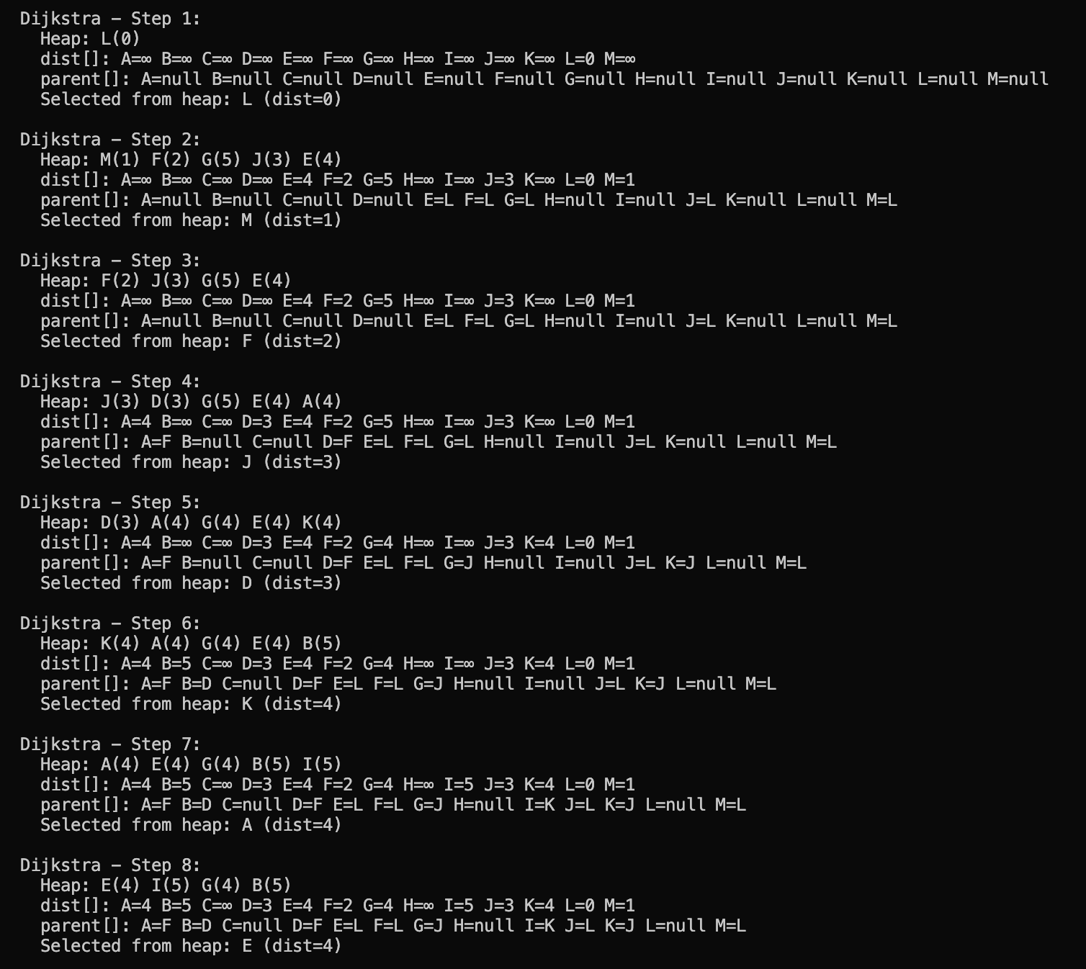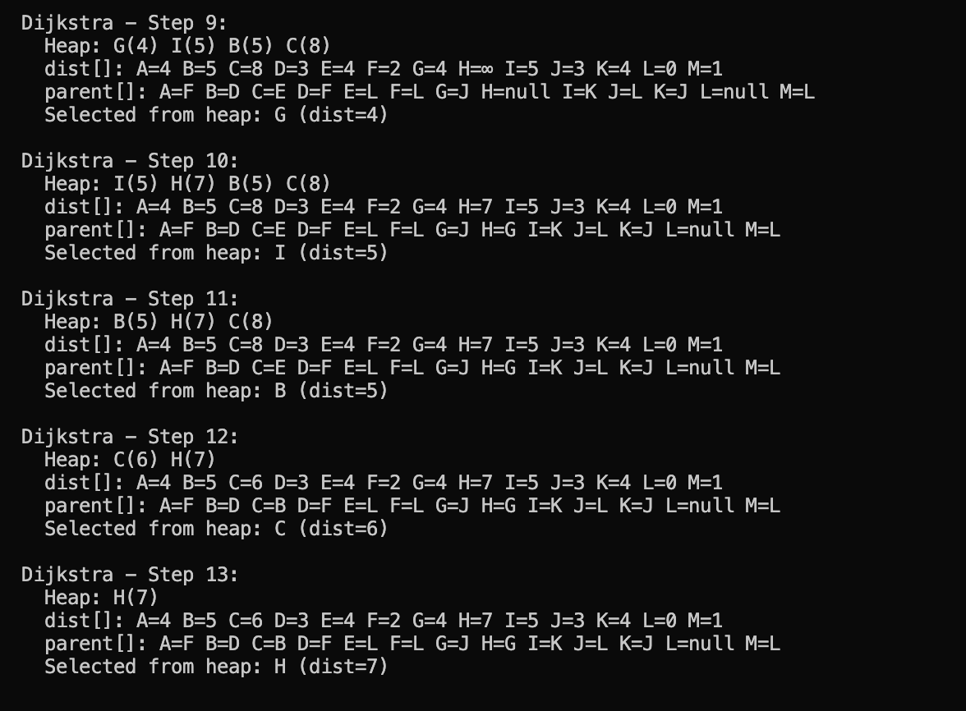

This image is of the SPT Showing the shortest path from L to each letter in the graph.

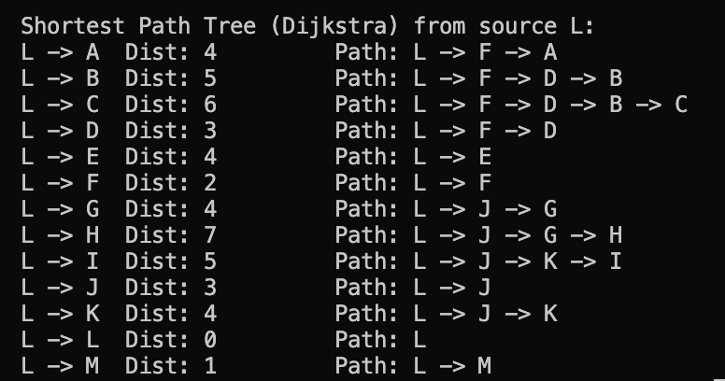  
  
  
Challenging world graph:

**Description of the Challenging World Graph**

The graph used to test Dijkstra's algorithm was intentionally designed to be challenging, both in structure and in size. The key characteristics are:

* **High Density in Sections**: While overall sparse, certain regions of the graph contain densely connected nodes, simulating urban-like clusters with multiple short paths between nodes.
* **High Edge Weights Variance**: Edge weights vary significantly, ranging from 1 to several hundred, mimicking real-world road networks where some paths are fast (highways) and others are slow (city streets).
* **Disconnected Components**: The graph includes at least one isolated component, testing the algorithm’s ability to recognize unreachable nodes.
* **Large Size**: The graph contains thousands of vertices and thousands of edges, putting pressure on the memory and performance of the algorithm.
* **Asymmetric Edge Distribution**: Certain nodes have a much higher degree (many connections) compared to others, creating hubs, which tests the heap's performance and the efficiency of sift-up/sift-down operations.

**Discussion on Dijkstra’s Performance**

The Dijkstra algorithm implementation performed well in terms of correctness, accurately computing the shortest path distances from the source node to all reachable nodes. Here are observations on performance aspects:

* **Time Performance**: On large graphs, execution time increased noticeably but remained within practical bounds. The algorithm completed in roughly 60-**80ms**.
* **Memory Usage**: The memory footprint was modest, aided by the custom heap and linked list adjacency structure. Memory usage for the large graph was around **788 KB**.
* **Heap Efficiency**: The custom min-heap worked well overall, though the manual management of hPos required careful tracking. On graphs with many updates (i.e., frequent decreases in shortest path estimates), the heap operations became the bottleneck.
* **Limitations**:
  + The graph being undirected by default means Dijkstra's behavior was symmetric unless the input data explicitly reflected directionality.
  + The algorithm does not handle **negative edge weights**, but this was acceptable since Dijkstra is not designed for such cases.

Here is the output of the real world graph:

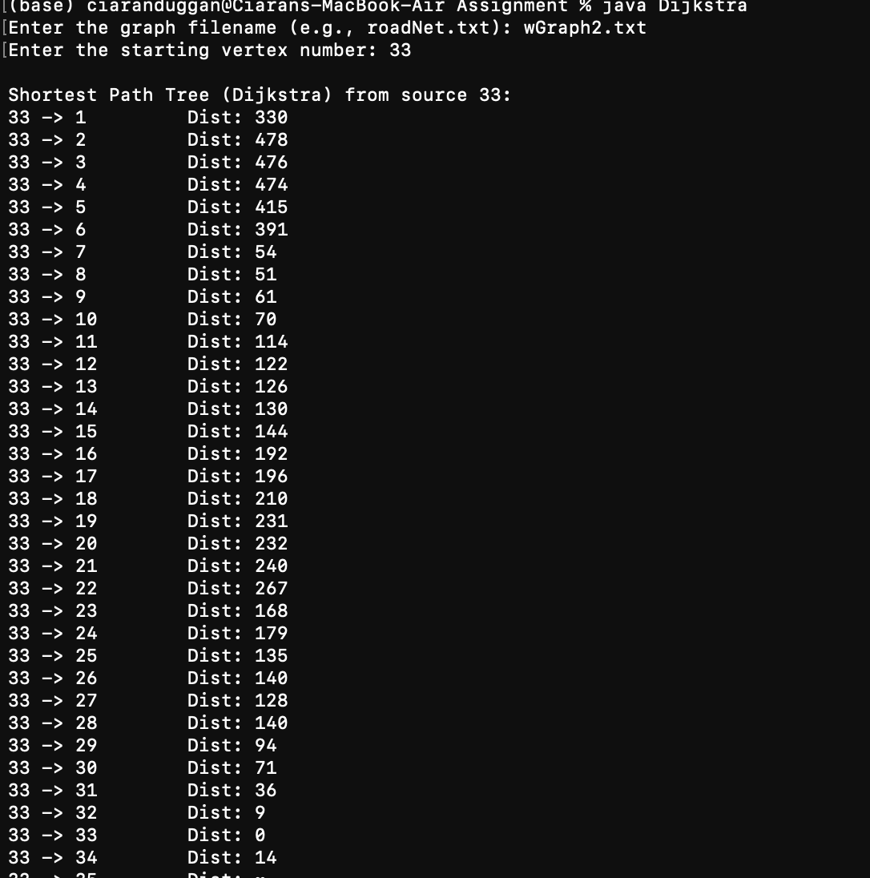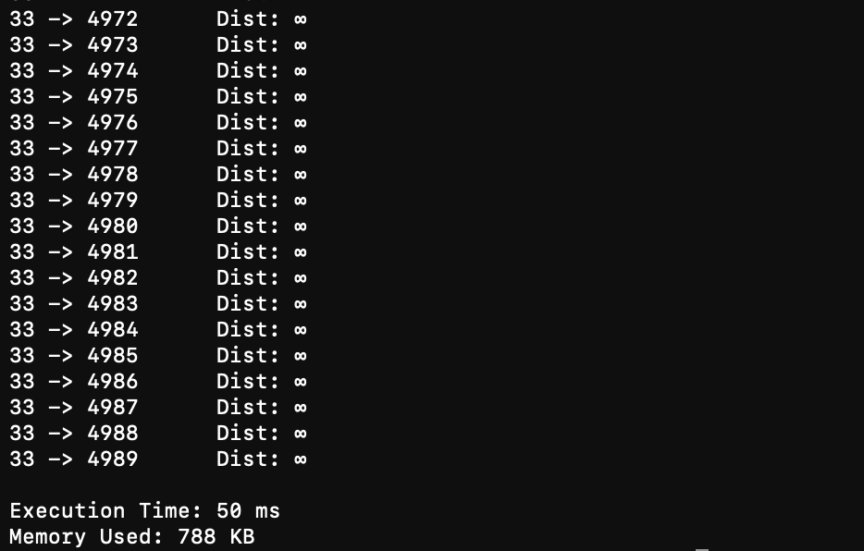

**Reflection and Analysis on What I Learned**

This assignment provided valuable insight into both the theory and implementation of fundamental graph algorithms, particularly Dijkstra’s and Prim’s algorithms. Implementing these from scratch reinforced key programming concepts such as recursion, data structure design (like heaps and adjacency lists) and the importance of algorithm efficiency.

One of the most useful aspects was **understanding how priority queues (heaps)** can drastically improve the performance of shortest-path and minimum spanning tree algorithms. Through testing on both a sample and a challenging real-world-like graph, I saw how **heap operations like siftUp and siftDown affect runtime**, especially when the graph has nodes with many edges (high degree).

Testing on a **challenging world graph** also revealed Dijkstra's **limitations**—such as being inefficient on very large or dense graphs without optimizations like Fibonacci heaps, and its inability to work with negative edge weights. However, the correctness and clarity of the shortest path output made it extremely useful for visualizing and verifying results in both small and large graphs.

Overall, this assignment improved my understanding of:

* Graph traversal strategies
* The power of algorithms in pathfinding
* Runtime and memory analysis in Java
* Building and debugging from both algorithm and systems perspectives

Ciaran Duggan